

**American International University- Bangladesh**

**CSC 2209: Object Oriented Programming 1 (JAVA)**

**CO1 Evaluation**

**Project Summary Report**

**Fall 2019-20**

**Group No: 10**

**Project Title: Job and Course Proposer (JCP)**

|  |  |
| --- | --- |
| Student Name | Student Id |
| Ehsanul Haque Antik | **18-36572-1** |
| Shafin Talukder | **18-36588-1** |
| Nayma Islam | **18-36607-1** |
| Tawhid Khondakar | **18-36611-1** |

**Introduction:**

Job and Course Proposer is an application that’ll help the newly joined university fresher’s and fresh graduates. A list of courses are provided that’ll help students to increase their skill in that particular field and a list of jobs are provided with necessary requirements that both graduate and undergraduate students can avail if they meet the required requirements by forwarding their CV to them.

**User Category:**

There are two types of Users in this application they are:

* Admin
* User

**Feature List:**

In this project the **Admin** has the following features:

* Manages members
* Grants/ deny access to member
* Manage users and admins right
* Manages users access to virtual spaces
* Blocks user
* Forwards response to user

In this project the **User** has the following features:

* Push notifications
* Mobile payment
* Security
* Feedback system
* Reliability
* Speed

**GUI Description:**

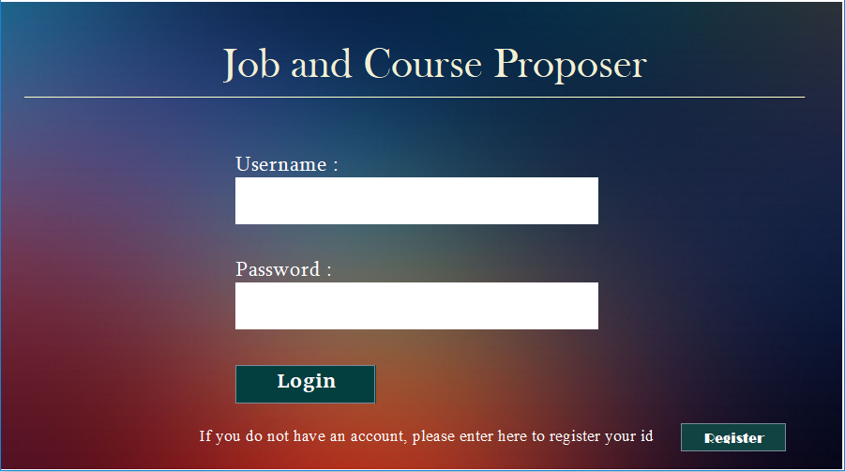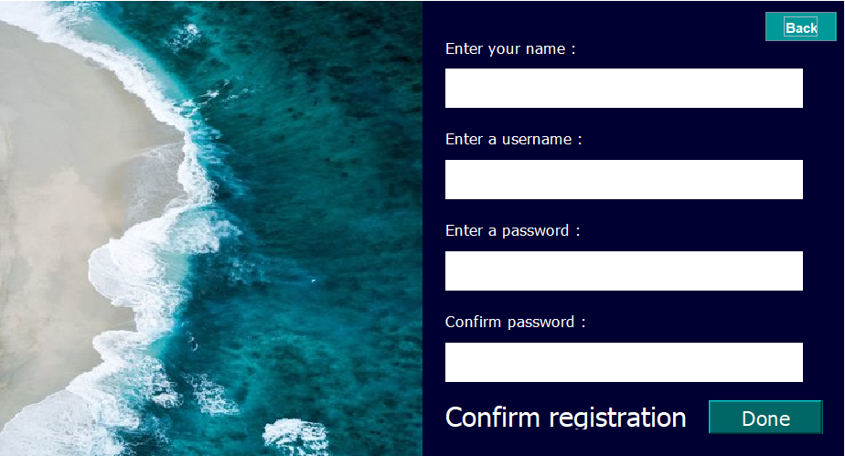

In case a person don’t have an account, he can easily create an account by providing necessary information in the following interface

Users can enter to the application by providing their valid username and password

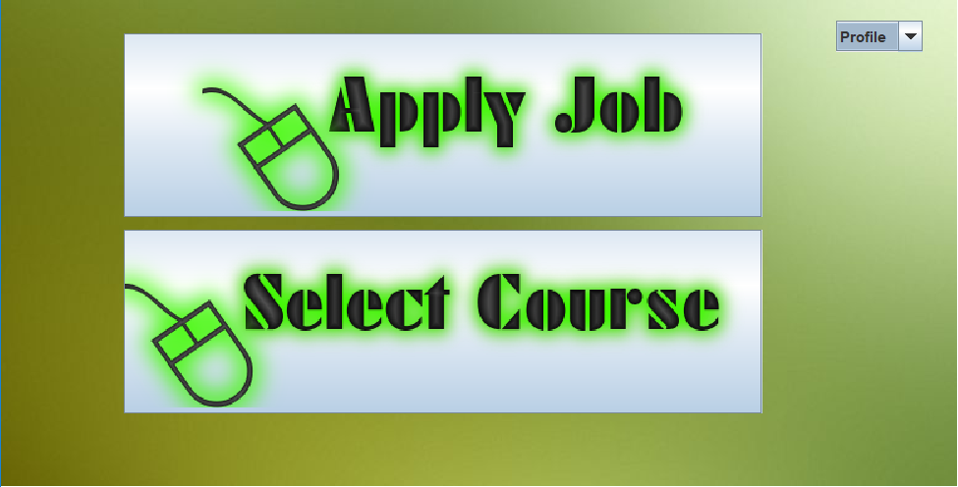

Selection of preferable manual

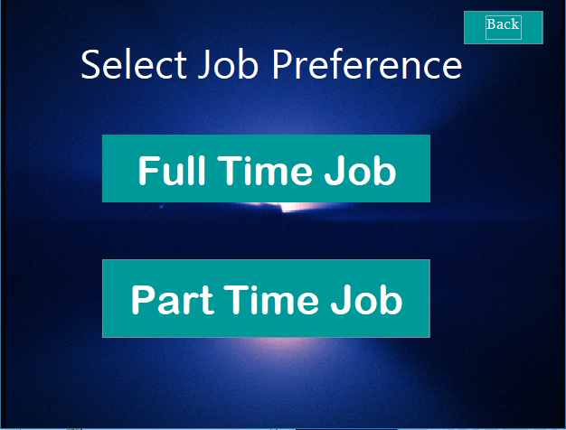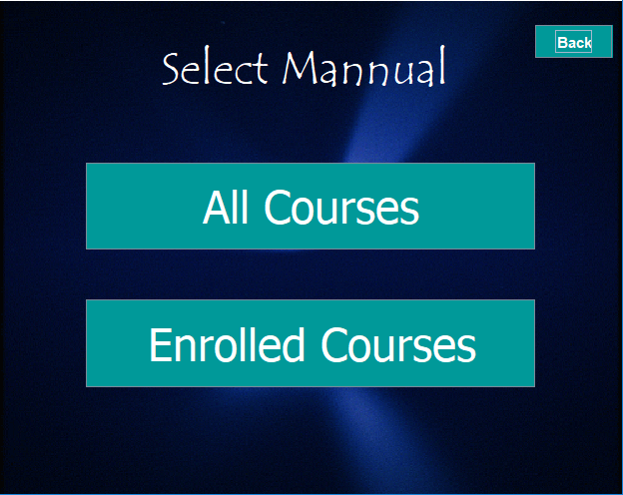

Select desirable job type

Check enrolled courses or available courses

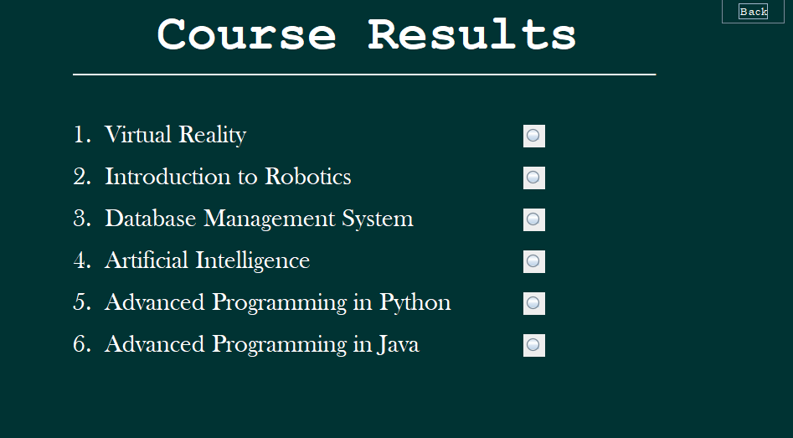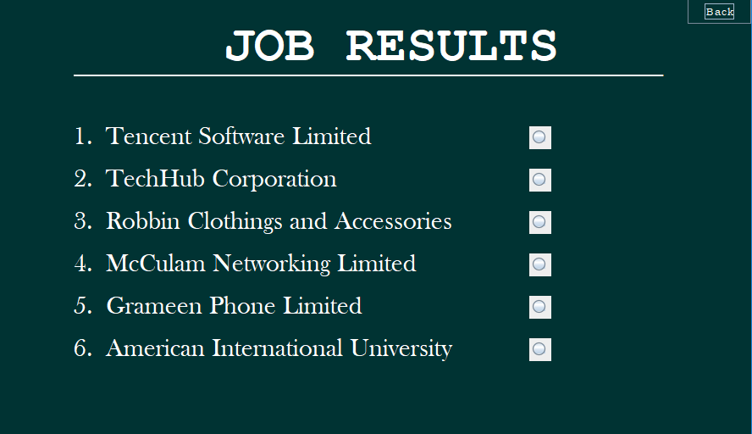

Available Courses Results

Available Job Results

**Database Table Description:**

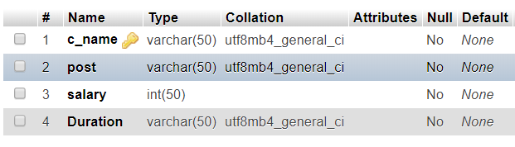

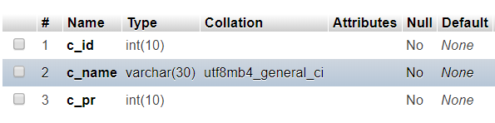

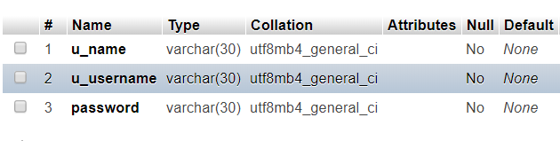

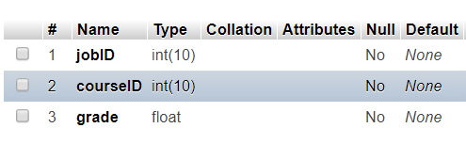

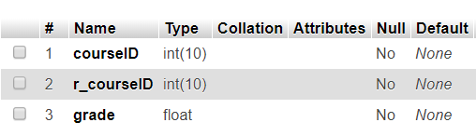

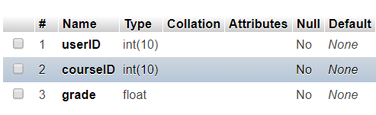

**Class Diagram:**

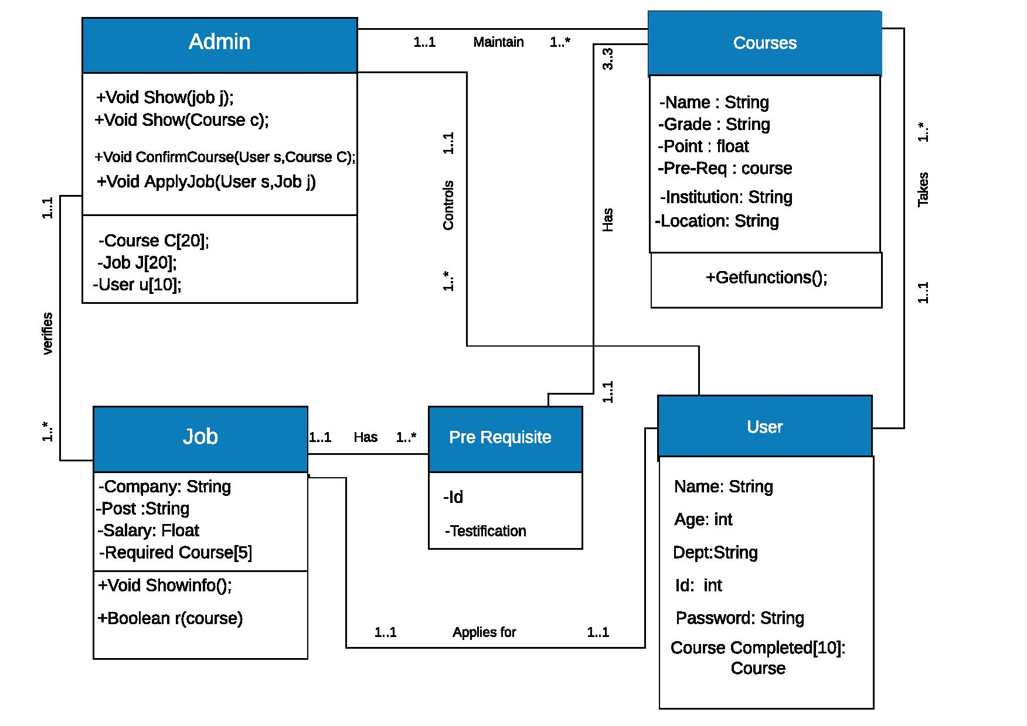

**Tools Used:**

To develop this project we have used the following:

* Netbeans
* Xampp
* Drag and Drop
* JDBC Connector

**OOP and Java Concepts Used:**

* Concept 1: Inheritance.
* Concept 2: Interface.
* Concept 3: Exception handling.
* Concept 4: Graphical User Interface.
* Concept 5: Java Database Connectivity.
* Concept 6: Events.

**Impact of this Project:**

The main motive behind this project is to help the fresher’s who are interested in CS but due to having lack of knowledge and importance of today’s tech world they are lacking behind skills and get rejected in jobs for not having the requirements they’re asked for. By the help of this application both fresher and a fresh graduate or other individual can acquire knowledge help build their skills and can prepare themselves for their desired job.

**Limitations and Possible Future Improvements:**

Lists of limitation in this application are:

* Internet reliance
* Usage situation
* Inaccurate clicks
* Amount of storage
* Size of screen

Lists of possible future improvements in this application are:

* Geo location
* Events on Programming contests
* Adding more courses
* Adding tutorial links on the available courses
* Providing course description and its advantages
* User friendly
* Suggesting requirement based courses
* Goals reminder